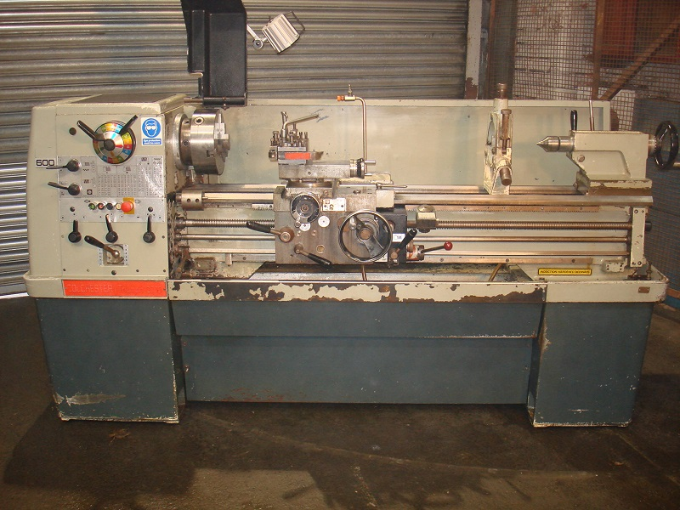
COLCHESTER TRIUMPH 2000 CENTRE LATHE,
Serial number…

Centre height…190mm
Swing over bed…390mm
Swing over cross slide…240mm
Distance between centres…1250mm
Spindle bore…54mm
Spindle speeds & No of changes…25 - 2000 rpm, 16
Main motor…7 ½ HP
Foot print…(LxWxH) 1930mm x 965mm x 1250mm

C/w 3/ 4 jaw chucks, Quick Change Tool-post Fixed Steady, Anijest Threading, light and Coolant.
Price £6750.00 +vat

